**-- Assignment 1**

**-- Task 1**

Use Ayush_Database;

Create or Replace Table Shopping_history (

Product varchar not null,

Quantity integer not null,

Unit_price integer not null

);

Insert into Shopping_history values

('Bread', 10, 20),('Eggs', 30, 7),('Milk', 12, 30),('Rice', 20, 70),('Sugar', 15, 45),('Tea', 19, 18),('Flour', 3, 32),('Coke', 14, 20),('Toy', 6, 80),('Salt', 3, 20);

Insert into Shopping_history values ('Bread', 7, 20);

select * from Shopping_history;

SELECT Product, Sum(Quantity * Unit_Price) as total_price from shopping_history

GROUP BY product

order by product desc;

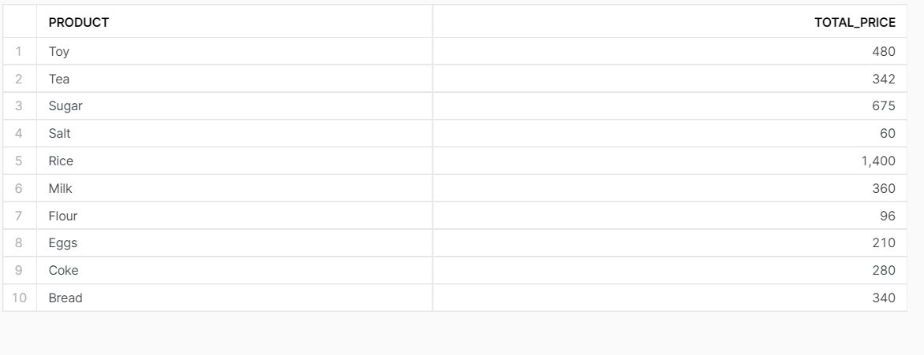

* **TASK 2**

Select p.name from phones p

join calls c on p.phone_number = c.caller

group by p.name

having sum(c.duration) >= 10;

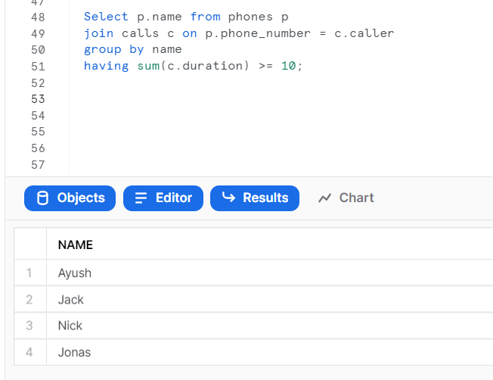

* TASK 3

Select (sum(a.total) - (12- count(b.cnt ))*5 ) as balance From

(Select sum(amount) as total , 'A' as name from transactions ) as a left join

(Select count(amount) as cnt , 'A' as name

From transactions

where amount <0

group by month(date)

having not(count(amount) <3 or sum(amount) >-100) ) as b

on a.name = b.name;